Exp.No-5
5. Write a C program for generalization of the Caesar cipher, known as the affine Caesar cipher, has the following form: For each plaintext letter p, substitute the ciphertext letter C: C = E([a, b], p) = (ap + b) mod 26 A basic requirement of any encryption algorithm is that it be one-to-one. That is, if p q, then E(k, p) E(k, q). Otherwise, decryption is impossible, because more than one plaintext character maps into the same ciphertext character. The affine Caesar cipher is not one-to-one for all values of a. For example, for a = 2 and b = 3, then E([a, b], 0) = E([a, b], 13) = 3. a. Are there any limitations on the value of b? b. Determine which values of a are not allowed.

Aim:
To implement the Affine Caesar Cipher encryption and determine the valid values of a and b.
Theory:
Encryption Formula:
$$C=\left(aP+b\right) 26$$
where:
- P = Plaintext
- C = Ciphertext
- a,b = Keys
Conditions:
- b can be 0–25 (no restriction).
- a must be coprime with 26.

Valid values of a:
1,3,5,7,9,11,15,17,19,21,23,25

Invalid values:
2,4,6,8,10,12,13,14,16,18,20,22,24,26

Algorithm:
- Read plaintext.
- Read values of a and b.
- Check gcd(a,26)==1.
- Encrypt every letter.
- Display ciphertext.
Program:
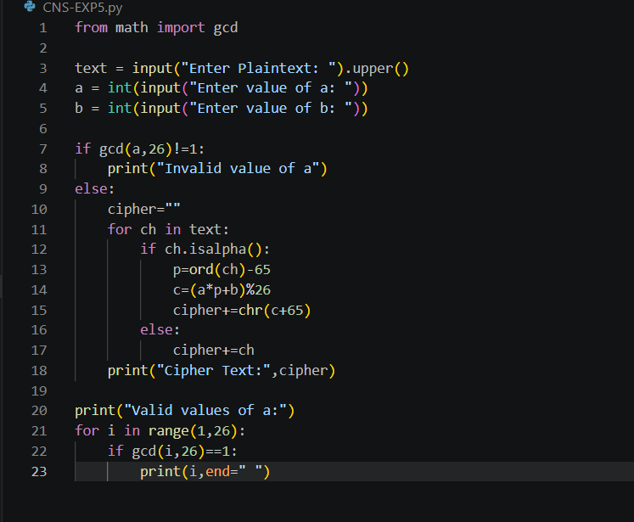
Output:
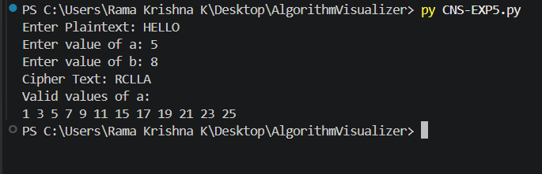
Result:
The Affine Caesar Cipher was successfully implemented. The value of a must be relatively prime to 26, while b can be any value from 0 to 25.

